Part 1:

1.

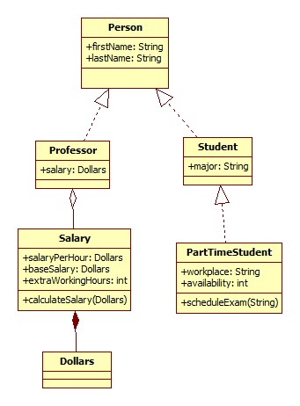

2.

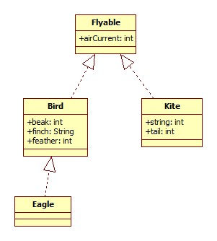

Part 2

1.

|  |  |
| --- | --- |
| ID | FR-01 Restaurant_Selection |
| 1. Description | This use case describe how the FoodeFits app will respond when user wants to select a restaurant. |
| 2. Actors | Primary: App user  Secondary: Cell phone, app |
| 3. Precondition | 1. User is connected to Wi-Fi or cellular network  2. App has an active connection with central server |
| 4. Basic Flows | 1. The use case begins when the App User opens the app  2. Use Case: *Validate User* via login is performed.  3. Based on previous usage of the app, the app provides option of visiting previously dined at restaurants  4. User selects previous restaurant and prompts for new selection  5. App shows restaurant selection.  6. App prompts for User input.  7. User swipes left or right in response to restaurant select.  8. Based on input, app displays more options to form unique algorithm.  9. App prompts for Dining buddy selection  10. User selects Yes or No for dining buddy.  11. App displays user results  12. App sends confirmation text message  13 The use case ends successfully. |
| 5. Alternative Flows | 5.1 Invalid User: If in step 2 of the basic flow App User, Use Case: Validate User does not complete successfully, then the use case ends with a failure condition.  5.2 Negative Responses: If the user in step 6 responds to all restaurant inquires with left swipes, the app will  - Access database for restaurant from a differing category  - The use case will resume at step 5 |
| 6. Post conditions | 6.1 Successful Completion:  App user receives restaurant suggestion and dining buddy if selected. User data is updated in database.  6.2 Failure Condition:  Crash logs have been updated accordingly. |
| 7. Special Requirements | 1. All restaurants in database are stated as open  2. User must be a registered member of the app |

Part 3